PROJECT DESIGN PHASE
Solution Architecture
Date | 03 October 2026
Team ID | SWTID-2026-8740
Project Name | Employee Data Management using ServiceNow Import Sets and Transform Maps
Maximum Marks | 4 Marks

Solution Architecture
The proposed architecture defines how employee information moves from an Excel spreadsheet into the ServiceNow employee table and how the resulting data is made available for review. The design separates data intake, staging, transformation, record matching, storage and reporting so that each part has a clear role.
Architecture and Data Flow
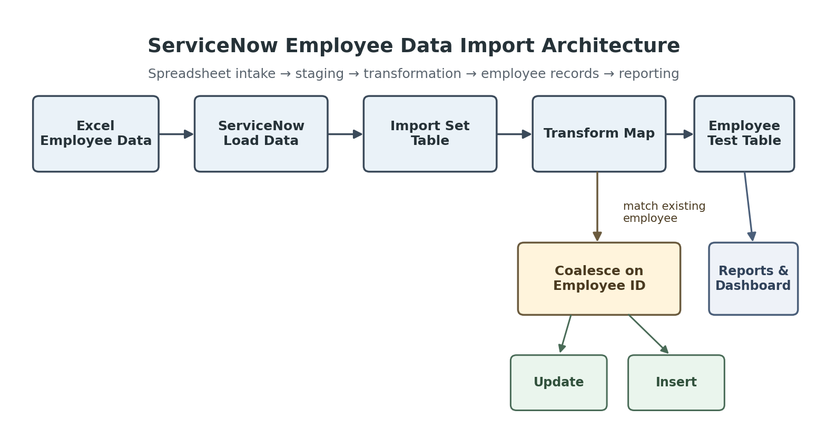
Figure 1: Solution architecture and data flow for the ServiceNow employee data import project.
Component Responsibilities
Component | Role in the Solution | Project Implementation
Excel Employee Data | Provides the source employee information for an import. | Employee ID, Employee Name, Email, Department and Location.
ServiceNow Load Data | Loads the spreadsheet and starts the import process. | Used to load the Excel file into ServiceNow.
Import Set Table | Acts as the staging area for incoming records before transformation. | Employee Import table.
Transform Map | Controls how source fields are mapped into the target table. | Sample Spreadsheet Import transform map.
Coalesce | Matches incoming data with an existing employee so the record can be updated instead of duplicated. | Employee ID used as the matching value.
Employee Test Table | Stores the transformed employee records. | Target table: Employee Test.
Reports | Summarize employee information for review. | Employees by Department, Employees by Location and Employee List Report.
Dashboard | Combines the reports into one monitoring view. | Employee Analytics Dashboards.
Architecture Flow
- 1. Data Source: Employee information is prepared in Excel.
- 2. Data Intake: The spreadsheet is loaded into ServiceNow through Load Data.
- 3. Staging: The incoming rows are held in the Employee Import table.
- 4. Transformation: The Transform Map maps the source fields to the Employee Test table.
- 5. Record Matching: Coalesce checks Employee ID to identify an existing employee.
- 6. Target Storage: New employees are inserted and matching employees are updated.
- 7. Visibility: Reports and the dashboard present the resulting employee information.
Architecture Characteristics
Characteristic | Design Consideration
Modularity | The workflow separates staging, transformation, record matching, storage and reporting.
Data Integrity | Coalesce provides a defined matching mechanism for existing employees and reduces duplicate creation during repeated imports.
Maintainability | Field mappings are managed through the Transform Map rather than requiring manual entry for every employee.
Usability | Reports and the dashboard provide a simple way for administrators to review employee information.
Extensibility | The design can be extended with additional fields, validation rules, scheduled imports and access controls as requirements grow.
Architecture Scope Note
This architecture represents the completed academic project scope. It does not assume external enterprise integrations, scheduled production imports, load balancing or measured production-scale performance because those features are not part of the supplied project implementation.
Reference
Supplied Solution Architecture template, Project Design Phase.

